NEURONS

Neurons are the basic functional unit of the central and peripheral nervous system. Sometimes called nerve cells, these specialized structures transmit, receive and process information using electrical and chemical signals.

You have sensory neurons, which respond to stimuli that affect your senses (touch, smell, taste, hearing, and vision). They convert that stimulus into an electrical signal sent to your brain, which processes the sensory input and initiates a response. For example, if something smells good, your sensory organs relay that information to your brain and your brain will respond by sending nerve impulses to your salivary glands, causing your mouth to water.

You have motor neurons for voluntary and involuntary movements of muscles (and your skeleton).

Lastly, you have interneurons, which connect motor and sensory neurons and transfer information between them. This is the reason you move your hand quickly when you touch something hot!

THE STRUCTURE OF NEURONS

There are several different shapes of neurons, but for simplicity, we will build a multipolar neuron.

STEP 1) THE CELL BODY AND DENDRITES

All neurons contain a cell body with dendrites that receive information from your organs, sense organs, muscles, or other neurons.

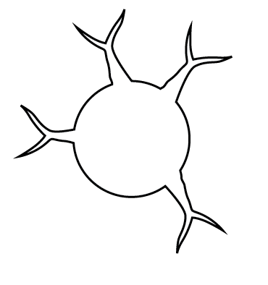The cell body is the round portion, and the dendrites are the branches that extend from the cell body.

Color this entire structure ORANGE. Cut it out, but do not glue it down yet.

STEP 2) ORGANELLES

Within the cell body are organelles, just like the rest of the cells in your body. To keep it simple, we will only show the nucleus and mitochondria.

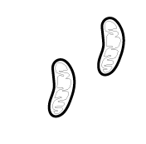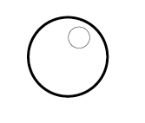

Color the nucleus PURPLE. Color the mitochondria RED

**Glue both of these structures inside of your cell body.**

STEP 3) AXON, AXON TERMINALS, AND SYNAPTIC BULBS.

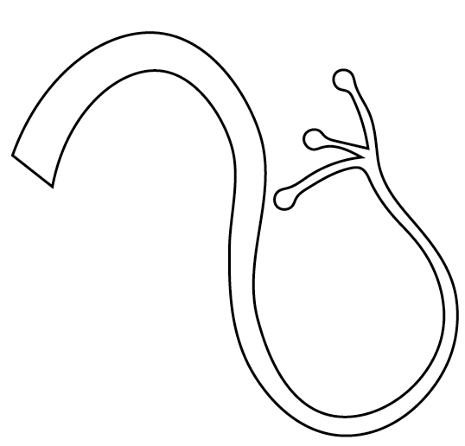Each cell body has an axon. Each nerve cell will send impulses down this tail toward the organ, muscle, or nerve it will affect. At the end of the tail, we have axon terminals and synaptic bulbs. In our diagram, they are the three branches with bulbs on them. These structures send signals to other neurons, or with muscles or organs.

Color this entire structure ORANGE:

**Glue the large, flat end to the back of the cell body.**

STEP 4) SCHWANN CELLS AND MYELINIZATION

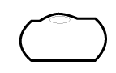Neurons also contain Schwann cells, which produce myelin sheaths that wrap around the axon at various points.

Color each Schwann cell and myelin sheath BLUE. **Glue them along the axon, roughly 1 inch apart.**

STEP 5) NODES OF RANVIER

Between each Schwann cell and myelin sheath, there are Nodes of Ranvier. It is a complicated process, but the myelin sheaths allow the nerve impulse traveling down the axon to “jump” from Node of Ranvier to Node of Ranvier. There are four nodes on your cut out sheet.

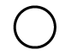

Color each node ORANGE. Glue a node in the space between each myelin sheath. You will have one left over. Glue it to the axon just after the last myelin sheath.

STEP 6) COMPLETE

**Glue your entire neuron down in your interactive notebook.**

You should have a page of labels for each structure on your neuron. Cut them out and paste them to your page. Using a ruler and a pen or marker, draw a line from the label to the appropriate structure on your neuron.